

**Fortitude Valley**

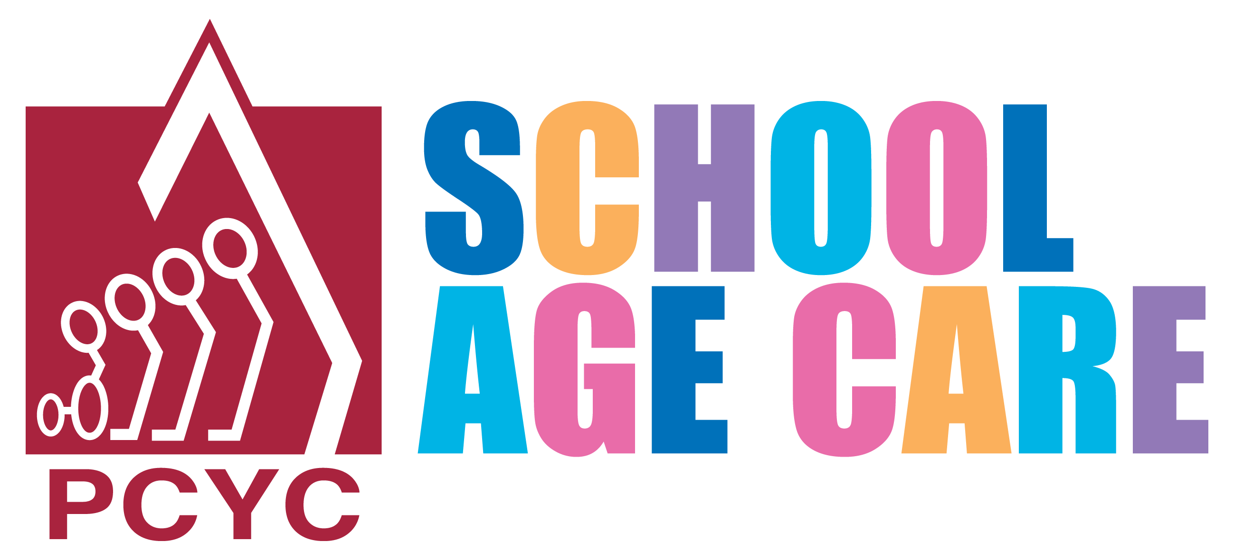



**Hamilton**

For Further Information

Please Call

0408 738 246

Or email

[theresa.totman@pcyc.org.au](mailto:theresa.totman@pcyc.org.au)

**PCYC Fortitude Valley**

**Hamilton**

**School Age Care**

**0428036179**

[hamiltonsac@pcyc.org.au](mailto:hamiltonsac@pcyc.org.au)

**Providing:**

BSC – 7.00am to 9.00am

At Ascot

ASC – 3.00pm to 6.00pm

Vacation Care is available at Ascot Service

**Costs:**

BSC – $ 12.00

ASC – $ 18.50

Our Service

Our aim is to provide a caring and secure environment where each child can develop his or her physical, intellectual, social and emotional skills to become a competent and confident individual.

We are committed to providing the highest quality care and to implementing sound child care principles to fully meet the needs of our children and their families.

Our Program

We believe our programs need to be flexible and adaptable to meet the individual and group interest, talents, needs, ages, strengths and energy levels. Working with children we have developed a program that is stimulating and involving and matches the interest of the children.

Our program includes a range of activities that meet the interest of all children.

**We believe that the primary focus of child care must be the individual child…**

**We believe that children learn by doing and that children learn through play……**

**We believe that children need to feel safe and secure in their child care environment ….**

**We believe that parents/caregivers are the most important people in a child’s life…..**

**We believe that the effective childcare worker focuses on thinking and processes, and has an understanding of the children’s learning ……**

Operating Times

Our After School Care service closes at 6.00pm and during this time children have a choice of indoor and outdoor activities.

Before School Care is available at Ascot After School Care 56 Barlow Street, Clayfield

Frequently Asked Questions

**Can I Receive the Child Care Benefits and Child Care Rebate for using your Program?**

All parents/caregivers with children attending the PCYC School Age Care service are eligible to receive Government Assistance towards their fees (Child Care Benefits and Child Care Rebate). Contact the PCYC Staff to find out how to apply for this assistance.

**Can I make Casual Bookings?**

Staff will endeavour to fit children into our program when needed. These casual bookings are conditional on availability of places and staff ratio. If your child does not have a permanent booking a fee of $21.50 will apply to any casual booking.

**How Much notice do I need to give when Cancelling Care?**

Cancellations require 48 hours notice. All cancellations less than 48 hours notice will be charged to your account.

**When are Fees Due and how Can I Pay?**

All fees are due one week in advance and payment is by Direct Debit.

**Are meals Included?**

A Healthy Light Snack is provide in After School Care

**POLICE-CITIZENS YOUTH CLUBS -** Enhancing Queensland communities through youth development.

PCYC SAC Form – SACN-7.2013

**MONTHLY**

**Club Name**



**POLICE-CITIZENS YOUTH CLUBS -** Enhancing Queensland communities through youth development.

